
FitTrack

MODULE TITLE :

Programming for information systems

Name: Konakanchi Sai Vyshnavi

Student ID : 20060603

Git hub : https://github.com/Saivyshnavi123/FitTrack.git

FitTrack

A Membership and Class Booking Information System for FIREFIT

Introduction and the Organisation
FIREFIT is a little independent gym located in south Dublin with two studios, which are Churchtown and Knocklyon. FIREFIT doesn’t offer any gym floor entry. Its main business revolves around small-group coaching classes such as strength training, spinning, HIIT, Hyrox, and Reformer Pilates, in which the maximum number of people enrolled in each class is eight to twelve, so the coach can help them in their posture corrections. Members buy a single membership that covers every class at both studios.
This particular organisation was selected as the domain size is sufficiently small to allow comprehension of all details while the booking situation is complex enough. A room cannot be given out at the mere request of the individual – it is based on whether or not the individual is an active member, whether his membership expires on the day of the class, whether there is room available in the class, whether he already has the place, and whether there is any conflict with other booking he has made for the day. These conditions interact, and getting them wrong costs the business money or goodwill.
Prior to the system, all this was done manually through the use of papers and spreadsheets. The problems that kept arising were foreseeable: overbooking classes, members who turned up with invalid membership status, and members booking themselves in for two concurrent classes.

Scope: a proof of concept, not a finished product

The task is such that it involves specifying all the needs of the information system and implementing just a piece of it as a prototype. This requirement has been adhered to with intent. The portion that is developed is the CRUD engine itself (planning, membership, class management and scheduling) along with its business rules and just one external integration that serves an actual business need because it drives a real business rule rather than decorating the interface.
The rest in Section 2 was all designed but never constructed. The reporting, member search and column sort, and the secondary integration with an external application were all designed, prototyped, and then stripped out to allow the slice we delivered to be complete, thoroughly tested, and line-by-line defended.

Requirements Specification
Functional requirements for the information system are shown in Table 1. Thirteen functional requirements have been defined, nine of which have been completely implemented, one has been partially implemented while the rest three have just been defined.

Table 1: Functional requirements and implementation status
Ref | Requirement | Status
FR1 | Full CRUD on membership plans | Implemented
FR2 | Full CRUD on members; expiry calculated from plan duration and start date | Implemented
FR3 | Full CRUD on classes; scheduling validated against instructor availability | Implemented
FR4 | Full CRUD on bookings, subject to the booking rules | Implemented
FR5 | Membership expiry enforced, so an expired member cannot book | Implemented (rule 3)
FR6 | Class capacity enforced, so a full class cannot be booked | Implemented (rule 4)
FR7 | Clash detection, so a member cannot hold two overlapping classes | Implemented (rule 6)
FR8 | Monthly class quota enforced per plan tier | Specified only
FR9 | Public holiday check, so classes cannot be scheduled on closure days | Implemented
FR10 | Session plan generated per class from an external exercise database | Specified only
FR11 | Search members; filter classes by date or instructor; sort by column | Partial
FR12 | Reports on expiring memberships, attendance rates and revenue by plan | Specified only
FR13 | Booking cancellation, freeing the place back to the class | Implemented

Non-functional requirements eight were given. NFR1 demands that Flask will only return JSON but not render any templates. NFR2 demands that all interactions should be performed using fetch() without reloading the page and without submitting forms. NFR3 demands foreign key integrity and transactional booking creation. NFR4 demands graceful degradation when an external API is unavailable. NFR5 demands parameterized SQL usage throughout. NFR6 demands a JSON envelope with proper HTTP codes. NFR7 demands that the system will not require any credentials and work from a fresh clone. All seven of these are implemented. NFR8, third party content attribution, is not relevant for the slice provided as there is no third party content, except for the exercise content which was removed.

System Architecture
The system is a Flask REST API over SQLite, with a vanilla JavaScript frontend that communi-cates exclusively through the Fetch API. Fig. 1 shows the arrangement.

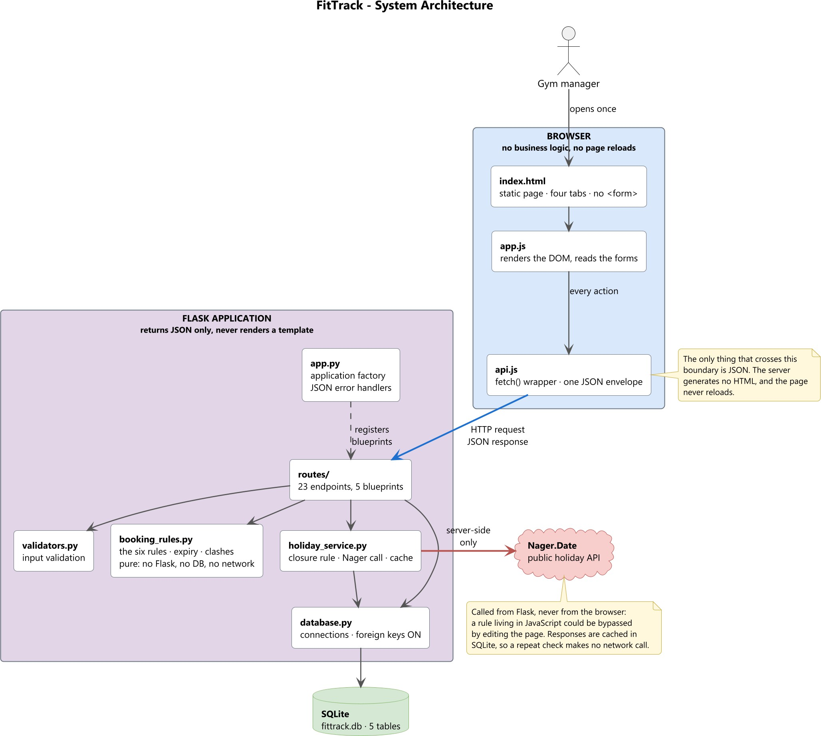

Figure 1: FitTrack system architecture. The browser holds no business logic and issues no page reloads; the only data crossing the boundary between the two halves is JSON. The public holiday API is called from Flask, never from the browser.

Two architectural rules are enforced throughout, and Fig. 1 is drawn to make both visible.
Flask returns JSON only and never renders a template. There is one static page, index.html, served using send_static_file. Not even framework errors are returned in anything other than JSON format, because error handling set up in create_app() catches all 400, 404, 405 and 500 codes so that an HTML error response is not possible. This REST API design is based on the architectural pattern outlined by Fielding [3].
The frontend never reloads. No <form> element exists on the user interface, which means there is no form submission at all; all events are handled via async requests made using Fetch API [2], and data is simply appended to the DOM. This is shown in Fig. 1 by the one blue arrow that represents the HTTP request sent from the browser to the server, and the only thing returning is JSON.
The backend is created through a Flask application factory, within which the application blueprints are registered, following the structure documented by Pallets [1]. The factory pattern is not decoration; it is what allows the test suite to construct a throwaway application against a temporary database for every test.
The layering in the application is rigorous. Route modules read the request and provide JSON envelope in response; there is no business logic there. The validators module validates the structure and types of input data. The booking rules module stores the rules as functions and imports only datetime, hence, does not interact with any database, networking or Flask. That is why this is the only module in Fig. 1 without any outgoing links; that is how the rules become unit-testable in isolation.

The holiday service is owns the external call and its cache, and the database module owns connections. Every response, whether success or failure, uses one envelope:
{ " success ": true , " data ": { ... } }
{ " success ": false , " error ": " Class is full", " details ": { " capacity ": 8 , " booked ": 8 } }

Database Design
The schema comprises five tables and four indexes. Fig. 2 shows the entities, their columns and the relationships between them.
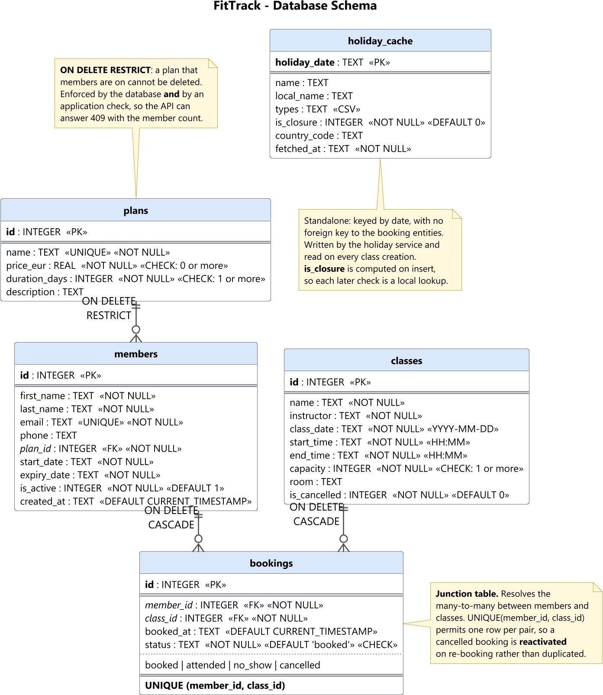
Figure 2: FitTrack database schema. The bookings table is the junction table resolving the many-to-many relationship between members and classes; the holiday cache is standalone, keyed by date, with no foreign key to the booking entities.

Relationships and delete rules
Bookings serves as the junction table that solves the many-to-many relationship between members and classes with the help of foreign key constraints [6]. There are three foreign keys, and the deletion rule of each is decided by the business relationship itself rather than being set arbitrarily.
The member plan reference uses ON DELETE RESTRICT. A plan that members are paying for must not be removable, because deleting it would orphan live memberships. Both booking references

cascade, because a booking has no meaning once either party to it is gone.
A UNIQUE(member_id, class_id) constraint permits exactly one row per member and class pair. This has a consequence explored in Section 5: a cancelled booking must be reactivated rather than duplicated.

Integrity is enforced twice
Integrity is maintained both in the database as well as in the application, to enable the API to give an explanation in English as to why the request cannot be honored. Deleting the plan that is held by members will result in a 409 error, along with the number of members holding the plan, since there is a check on the route before the delete operation, although there is a RESTRICT clause too and would refuse the operation even if the check were removed.
Perhaps the most significant feature about this schema is that it does not appear in the schema file itself. The foreign key constraints in SQLite are not active until they are explicitly activated, separate from the database connection [4]. In the database module, the execution of the command PRAGMA foreign_keys = ON is done when establishing the database connection; including it in the schema file alone will not activate it in future connections, and every RESTRICT and CASCADE rule described above would be silently inert.
All SQL commands that have values passed from outside use parameter placeholders, adhering to the OWASP guideline of using prepared/parameterized queries as the key countermeasure against SQL injection attack [5].

CRUD Implementation
The API exposes twenty-three endpoints across five Flask blueprints. Table 2 summarises them.
Table 2: API endpoints by resource

Resource | Create | Read | Update | Delete | Additional
/api/plans | POST | GET, GET/id | PUT | DELETE
/api/members | POST | GET, GET/id | PUT | DELETE | POST /id/renew
/api/classes | POST | GET, GET/id | PUT | DELETE | PATCH /id/cancel
/api/bookings | POST | GET, GET/id | PATCH /id/status | DELETE
/api/holidays |  | GET/year

Each of the four tabs in the interface follows the same shape: a form that creates, a table that reads, and per-row buttons that update and delete. Fig. 3 shows the plans view.
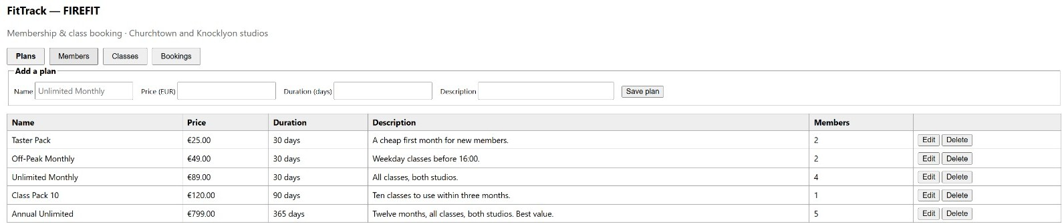

Figure 3: Plans view. Members is a live count from a join, not a stored one, which is what the delete validation looks at before refusing to delete the plan.

Members: calculation, not just storage
The members resource is the clearest demonstration that the API does work rather than merely persisting what it is given. Fig. 4 shows the view.

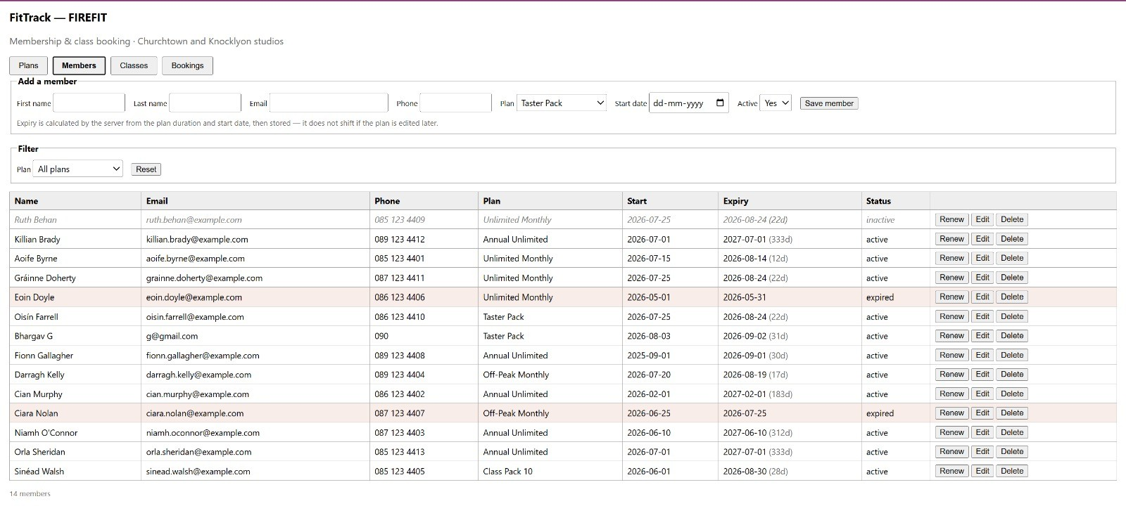

Figure 4: Members view. Expiry is never typed by the user. Expired rows are shaded and inactive rows italicised, both derived server-side from the stored expiry date and the active flag.

The creation of a member entails the submission of a plan along with the start date; the server finds out how long the plan lasts, adds that to the start date in days, and saves it. It doesn’t recalculate upon reading. This is important since if the expiry date was to be calculated upon reading, any changes made to the plan after that point would shift the expiry dates of all members on that plan. Storing it freezes the contract the member actually bought.
An update will recompute expiry only if there has been a change in the plan or the start date. Updating a different aspect, such as fixing a wrong phone number, won't affect the stored expiry and thus cannot cause any unintended discarding of a renewed plan. Renewing starts counting from the current expiry for an active membership, while it counts from the current day for a lapsed one to avoid an expired membership being generated, because back-dating a renewal would produce a membership that is still expired.

Classes: cancel and delete are different operations
Fig. 5 shows the class timetable. Each row offers Edit, Cancel and Delete, and the middle one is not a synonym for the last.

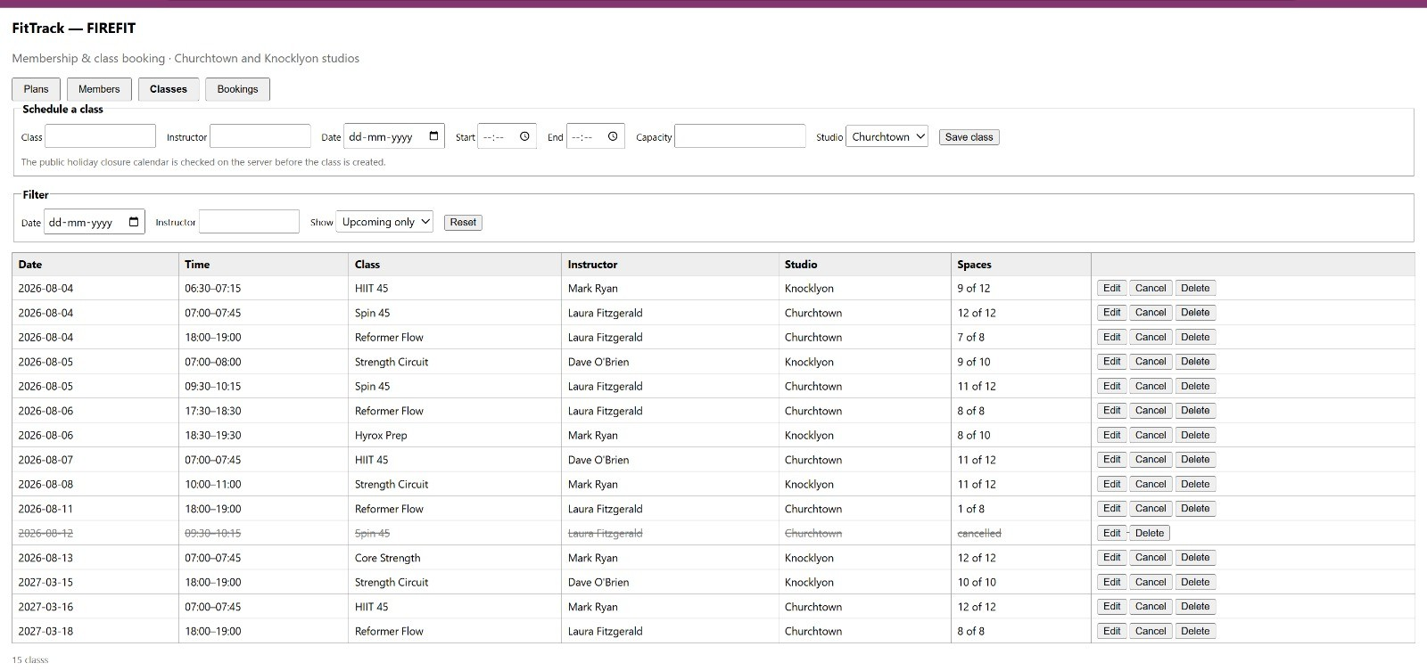

Figure 5: Classes view. The struck-through row is a cancelled class: it remains in the timetable and keeps its bookings, but accepts no new ones. The Spaces column is computed per class from bookings whose status is booked or attended.

In cancellation, the flag will be added, but the class will stay and keep all the history of that class. In deletion, both the class and its booked reservations will get deleted. But there is one more condition where we will be safeguarding the existing data, which is the capacity will not be changed below booked ones.

Bookings: cancellation without deletion
This resource of bookings does not have any destructive delete action. This can be seen in Fig. 6 below which shows the view and Fig. 7 which shows the response to a booking.
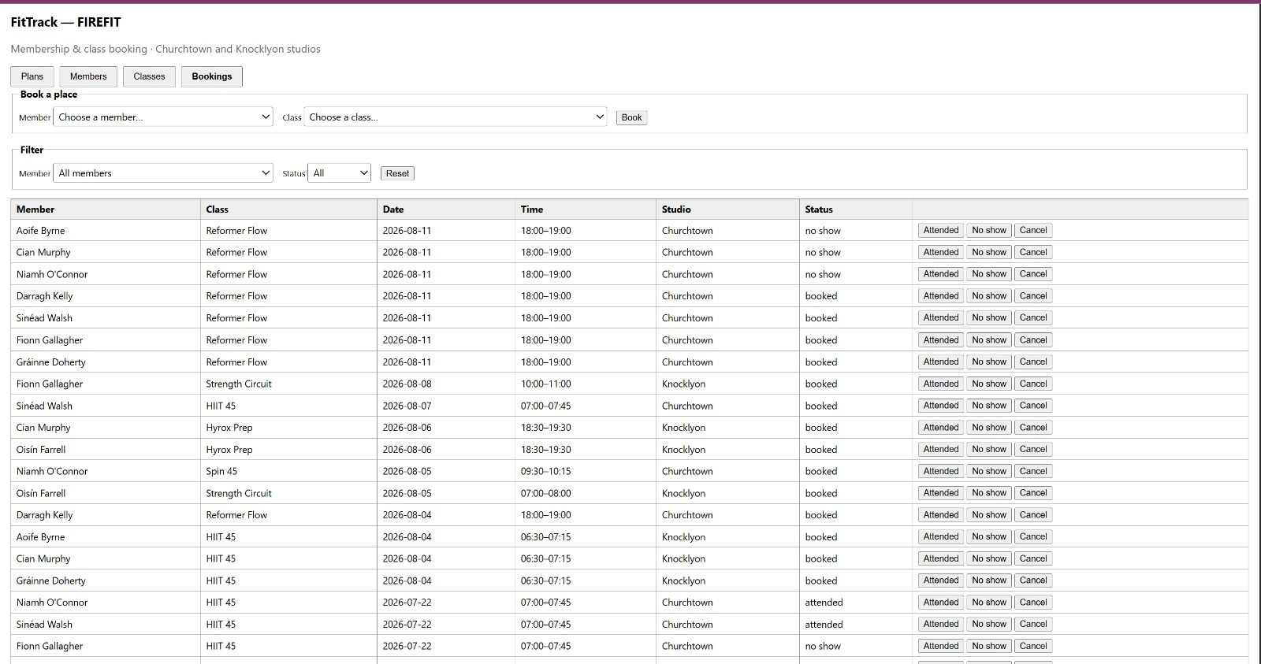
Figure 6: Bookings view, joining both member and class. Status can either be booked, attended, no show, or canceled, limited by the use of the CHECK constraint in the schema.

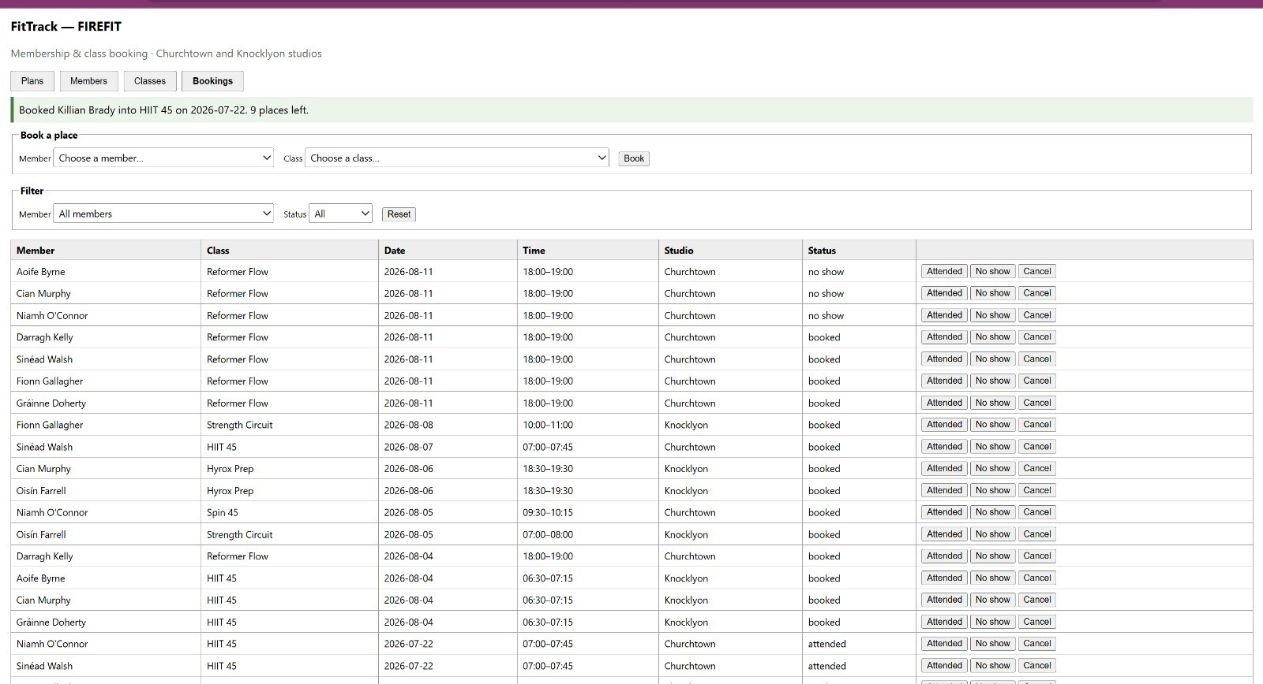
Figure 7: A booking that succeeds. The confirmation returns the available seats, which are calculated during the same transaction in which the booking was made, thus ensuring that the available seats returned by the confirmation cannot be out of date.

The cancel button sends a deletion message, but the handler sets the status as cancelled and maintains the row. Due to the uniqueness of UNIQUE (member_id, class_id), it is not possible to create a duplicate entry. Thus, re-booking the seat will have to activate the old record instead of creating a new row, since the response includes the reactivated flag to notify the caller about the situation. The gym always has one auditable row for each member-class combination, while the freed spot becomes instantly available due to the booking and attendance count.

Status codes

Those requests that cannot be satisfied due to conflicting with the state of a resource will receive
409 Conflict status, whereas syntactically correct requests that cannot be executed due to semantic issues will receive 422 Unprocessable Content status [7]. In the case of creating a member without an existing plan identifier, we have a good-formed request with semantic issues; hence, the implementation returns 422 status code. In the case of booking a non-existing member or a class, the response code returned is 404 since the resource being referred to does not exist anymore. RFC 9110 defines the codes; this particular mapping is the application’s chosen policy.

Business Logic and External Integration

The six booking rules
The booking request is compared with six rules that have to be followed in a definite sequence, and the first failing condition is reported. The six rules that have to be considered for this process are described in Table 3 below.

Table 3: The six booking rules, checked in order

# | Condition | Response when it fails
1 | Member exists and is active | 409 Member is not active
2 | Class exists and is not cancelled | 409 Class has been cancelled
3 | Membership expiry is on or after the class date | 409 Membership expires
 |  | before this class
4 | Places taken are fewer than capacity | 409 Class is full
5 | Member holds no live booking for this class | 409 Already booked
6 | No time overlap with another booking that day | 409 Clashes with an existing
 |  | booking

This is an intentional arrangement, not a coincidental one. In the case where a member tries to schedule an additional time slot for a class that is already full, rules 4 and 5 are both broken; but since rule 4 is processed first, the answer will be “this class is full.” The member receives information on the issue that needs solving first, and the response is deterministic rather than dependent on evaluation order.
There are two boundary rules that should be mentioned. First, an expired membership until the date of the class is considered to be valid, so rule 3 should be compared with ≥ but not with > since the last date is still valid. In regards to the clash detection rule, strict inequalities are used, so classes ending and starting at 18:30 will not clash and both may be held.
There is only one way of doing the overlap check and that is through the rule 6 above and the availability check of instructors when scheduling the classes. This will ensure consistency in the application of both rules.

The closure rule, derived from live data rather than assumption
The integration that we perform with an external entity is called Nager.Date. This provides holidays in Ireland [9]. We chose it because it helps us implement a business rule that determines if a class can be scheduled or not.
Naively thinking and putting a block on scheduling based on any returned holiday is wrong in our case. The application is integrated with Nager.Date version 3 and its response contains a field called types. Good Friday is categorized as Bank & School in Irish Calendar, but other public holidays contain Public and the closure rule determines whether Public is in the types array. On Good Friday banks and schools are closed, but the gym is open. If we put a block on each holiday, then it will close FIREFIT on a day when it opens lost a day’s revenue.
This rule came out of reading the live API response while developing the application and is not based on any guess about the contents of a holiday feed. Consequently, Bank or School only day is okay, and the response comes with a warning about which holiday to notify the manager of.
The call is made from Flask and never from the browser, for two reasons: a rule living in JavaScript could be bypassed by editing the page, and a response fetched by the browser could not be cached server-side. Each year is fetched once and written to the holiday cache with the closure flag computed on insert, so every later check is a local lookup.
Four paths are implemented and tested: a live fetch that populates the cache; a cache hit that makes no network call at all; an API failure for a year already cached, answered from the cache; and an API failure for an uncached year, which permits the class with a warning. The last is a deliberate trade-off in favour of availability, because an unusable scheduling screen is worse than a class scheduled on a closed day, which a human will notice.

Concurrency
Two members competing for the last place must not both receive it. Booking creation begins with
BEGIN IMMEDIATE, which starts a write transaction immediately rather than waiting for the first

write statement [8]. The capacity check and the booking insertion therefore occur within the same write transaction, preventing another writer from changing the booking count between the check and the insert. A threaded test asserts that of two simultaneous attempts on a class with one place remaining, exactly one succeeds.

Testing and Validation
The suite comprises twenty automated tests achieving 94% statement coverage of the application code, measured over 723 statements. Each test receives a unique temporary directory from the pytest tmp_path fixture, and the fixture creates a separate SQLite database within it; tests there-fore share no database state [10]. Nager.Data field is filled not with the fabricated values but with the values captured as a part of the payload, thus testing the production parser. Table 4 illustrates the distribution.
Table 4: Test suite composition

File | Tests | Coverage
test_plans.py | 2 | CRUD, duplicate name, delete blocked by RESTRICT
test_members.py | 2 | CRUD, calculated expiry, renewal, cascade
test_classes.py | 2 | CRUD, instructor clash, capacity floor, cancellation
test_bookings.py | 5 | All six rules, rule ordering, cancel and rebook,
 |  | concurrency
test_rules.py | 3 | Interval overlap, expiry boundaries, closure
 |  | classification
test_external.py | 3 | All four holiday paths including both failure modes
test_integration.py | 3 | Full stack, asserted against SQLite directly
Total | 20 | 94% statement coverage

For the assessment, there must be tests for the CRUD operations, and an integration test should be done too. There are three integration tests, which test the database and also the API, since a response code of 200 tells you nothing about whether the data was actually stored. If you write a test for creating a member and test only the response body, you could still get a pass result.
The testing process also helped rectify an error in the design which is worth mentioning. In the course of examining another integration, it was initially assumed that all exercise data came with an English translation because the counts of the results returned by filtered and unfiltered queries were equal. But equal counts do not mean complete coverage; on the contrary, they indicate that one of the parameters of the query has been overlooked. The actual state of affairs was confirmed by checking three hundred records on different result pages established the real position, and the retraction was recorded rather than quietly corrected. The integration was subsequently cut on scope grounds.

Reflection and Conclusion
The proof-of-concept delivered has implemented the CRUD principles in four entities, six booking principles that apply to the CRUD and one integration principle that determines the existence of a class. This is done from a clone that has no account setup whatsoever.
There are three things that would have been done differently. The second external integration should have been scoped before implementation rather than investigated and cut, although the investigation produced a genuine correction to a false assumption. Reporting was specified in full but not attempted, and is the obvious next increment: expiring memberships and per-class attendance rates are both single queries over data the schema already holds. Member search and column sorting were cut for the same reason, and would be a small addition.
The strongest part of the work is not the CRUD, which is conventional, but the closure rule. It

is the point at which the system stopped reflecting an assumption about the domain and started reflecting the domain itself, and it was only found by reading what the API actually returned.

Attributions
Flask (BSD-3-Clause) provides the REST API framework. SQLite (public domain) provides data storage. Requests (Apache 2.0) performs the server-side external API calls. pytest (MIT) runs the test suite and coverage.py (Apache 2.0) measures it. Public holiday data is supplied by Nager.Date (MIT) [9]. No third-party content requiring per-item attribution is displayed by the delivered system.

References
- Pallets, “Application factories,” Flask Documentation 3.1.x. [Online]. Available: https://flask. palletsprojects.com/en/stable/patterns/appfactories/. [Accessed: Aug. 2, 2026].
- MDN contributors, “Fetch API,” MDN Web Docs, 2026. [Online]. Available: https://developer. mozilla.org/en-US/docs/Web/API/Fetch_API. [Accessed: Aug. 2, 2026].
- R. T. Fielding, “Architectural styles and the design of network-based software architectures,” Ph.D. dissertation, Univ. of California, Irvine, CA, USA, 2000. [Online]. Available: https://ics.uci.edu/
~fielding/pubs/dissertation/top.htm. [Accessed: Aug. 2, 2026].
- SQLite, “SQLite foreign key support,” 2026. [Online]. Available: https://sqlite.org/foreignkeys. html. [Accessed: Aug. 2, 2026].
- OWASP Foundation, “SQL injection prevention cheat sheet,” OWASP Cheat Sheet Se-ries. [Online]. Available: https://cheatsheetseries.owasp.org/cheatsheets/SQL_Injection_ Prevention_Cheat_Sheet.html. [Accessed: Aug. 2, 2026].
- T. M. Connolly and C. E. Begg, Database Systems: A Practical Approach to Design, Implementation, and Management, 6th ed. Harlow, U.K.: Pearson Education, 2015.
- R. Fielding, M. Nottingham, and J. Reschke, Eds., “HTTP semantics,” Internet Engineering Task Force, RFC 9110, Jun. 2022. [Online]. Available: https://www.rfc-editor.org/rfc/rfc9110.html. [Accessed: Aug. 2, 2026].
- SQLite, “Transaction,” 2026. [Online]. Available: https://sqlite.org/lang_transaction.html.
[Accessed: Aug. 2, 2026].
- Nager.Date, “Nager.Date: Public holiday API documentation,” 2026. [Online]. Available: https:
//date.nager.at/Api. [Accessed: Aug. 2, 2026].
- pytest development team, “How to use temporary directories and files in tests,” pytest Documentation. [Online]. Available: https://docs.pytest.org/en/stable/how-to/tmp_path.html. [Accessed: Aug. 2, 2026].

